Exploratory Data Analysis Report
Course Name & Code : Fundamentals of Data Science (DSA04)
EDA on 5 datasets: Education,Healthcare,Retail, Banking,and Agriculture.

Question 1: Education Analytics Dataset
Goal: Analyze student performance based on attendance, study hours, and internal marks to find out what affects Result (Pass/Fail).
Column Name | Data Type
Student_ID | str
Attendance | int64
Study_Hours | int64
Internal_Marks | int64
Result | str
Dataset Information
Property | Value
Shape (Rows, Columns) | (20, 5)
Total Rows | 20
Total Columns | 5
Missing Values | 0
Duplicate Rows | 0
Statistic | Attendance | Study_Hours | Internal_Marks
Count | 20.0 | 20.0 | 20.0
Mean | 70.15 | 3.35 | 32.95
Standard Deviation (Std) | 15.94 | 1.42 | 9.09
Minimum (Min) | 45.0 | 1.0 | 18.0

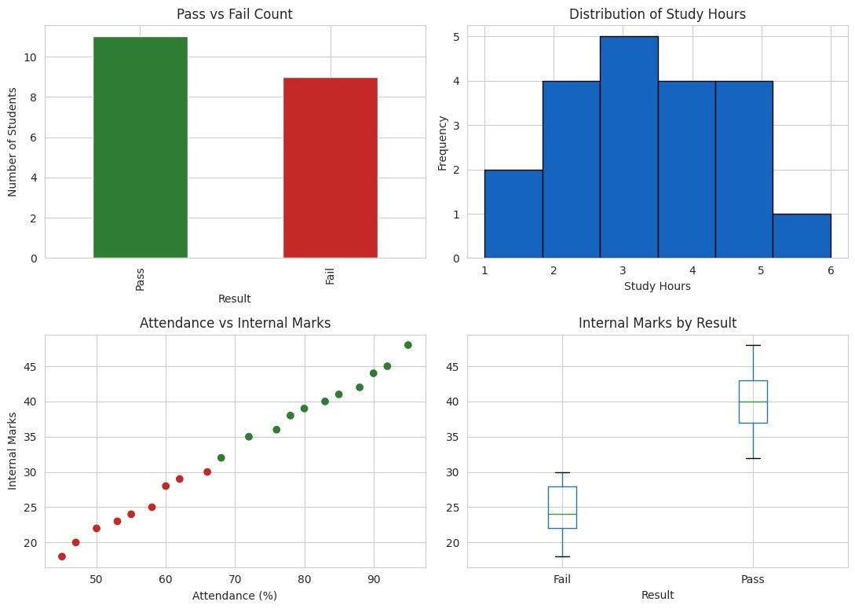
Descriptive Statistics
Statistic | Attendance | Study_Hours | Internal_Marks
25% (Q1) | 57.25 | 2.00 | 24.75
50% (Median) | 70.00 | 3.00 | 33.50
75% (Q3) | 83.50 | 4.25 | 40.25
Maximum (Max) | 95.00 | 6.00 | 48.00

Observations
Observation No. | Description
1 | Students with attendance above 75% mostly pass.
2 | Higher study hours generally lead to higher internal marks.
3 | Students who fail usually have internal marks below 30.
4 | Attendance and internal marks show a positive relationship.
5 | No missing values or duplicate records were found in the dataset.
Conclusion
Attendance and study hours are strong indicators of student performance. Students with higher attendance and more consistent study hours generally achieve better internal marks and are more likely to pass. The dataset also contains no missing values or duplicate records, indicating good data quality. Therefore, students should be encouraged to maintain high attendance and regular study habits to improve their academic performance.
Question 2: Healthcare Analytics Dataset
Goal: Analyze patient health risk based on age, sugar level, BP, and BMI to identify patterns related to disease status.
Dataset Information
Property | Value
Shape (Rows, Columns) | (20, 6)
Total Rows | 20
Total Columns | 6
Missing Values | 0
Duplicate Rows | 0
Column Data Types
Column Name | Data Type
Patient_ID | str
Age | int64
Sugar_Level | int64
BP | int64
BMI | int64
Disease_Status | str
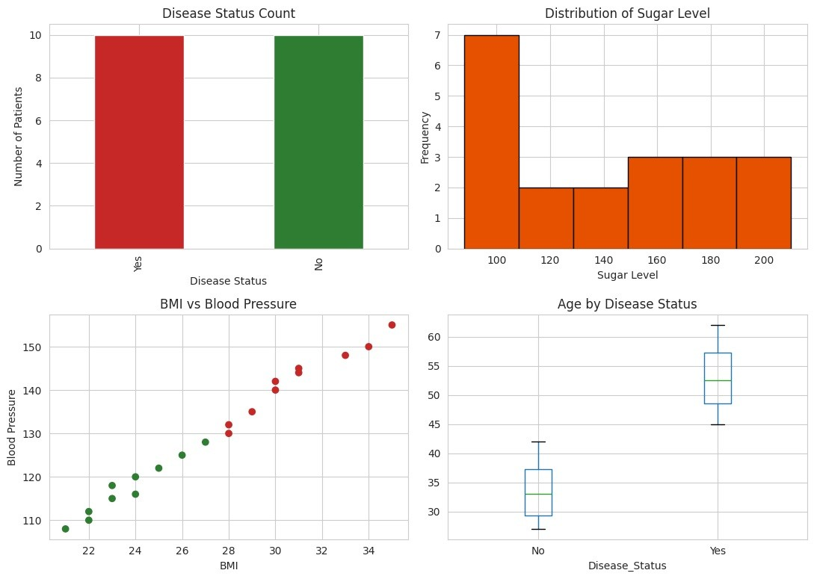
Descriptive Statistics (Numeric Columns)
Statistic | Age | Sugar_Level | BP | BMI
Count | 20.0 | 20.0 | 20.0 | 20.0
Mean | 43.20 | 138.65 | 129.75 | 27.30
Standard Deviation (Std) | 11.32 | 40.33 | 14.52 | 4.26
Minimum (Min) | 27.00 | 88.00 | 108.00 | 21.00
25% (Q1) | 33.50 | 99.50 | 117.50 | 23.75
50% (Median) | 43.50 | 137.50 | 129.00 | 27.50
75% (Q3) | 52.25 | 171.25 | 142.50 | 30.25
Maximum (Max) | 62.00 | 210.00 | 155.00 | 35.00
Observations
Observation No. | Description
1 | Patients with sugar levels above 140 mostly have Disease_Status = Yes.
2 | Higher BMI is associated with higher blood pressure.
3 | Older patients (above 45 years) show a higher risk of disease.
4 | Disease-positive patients tend to have higher BP and BMI values together.
5 | The dataset is clean with no missing values or duplicate records.
Conclusion
Sugar level, BMI, and blood pressure together are strong indicators of disease risk. Patients with higher values in these factors are more likely to have a positive disease status. Since the dataset contains no missing values or duplicate records, it is suitable for reliable analysis. Regular monitoring of sugar level, BMI, and blood pressure can help in the early detection and management of disease risk.
Question 3: Retail Sales Dataset
Goal: Analyze product sales based on category, price, quantity sold, discount, and revenue to identify high-selling products.
Dataset Information
Property | Value
Shape (Rows, Columns) | (20, 6)
Total Rows | 20
Total Columns | 6
Missing Values | 0
Duplicate Rows | 0
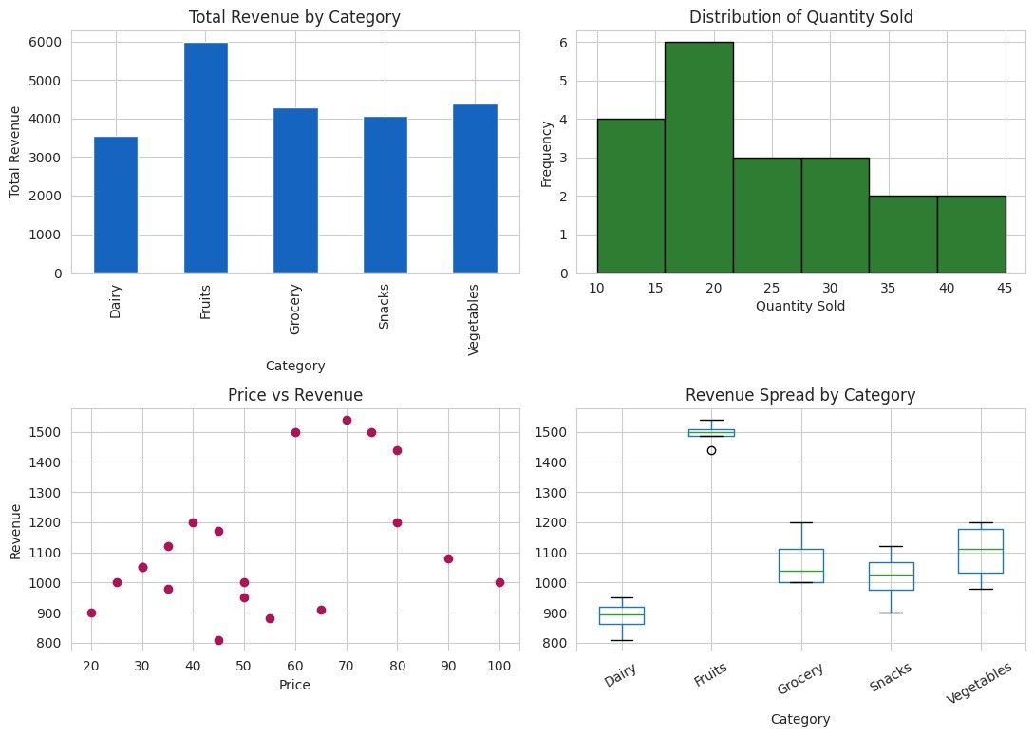
Column Data Types
Column Name | Data Type
Product_ID | str
Category | str
Price | int64
Quantity_Sold | int64
Discount | int64
Revenue | int64
Descriptive Statistics (Numeric Columns)
Statistic | Price | Quantity_Sold | Discount | Revenue
Count | 20.0 | 20.0 | 20.0 | 20.0
Mean | 54.00 | 24.00 | 4.00 | 1114.00
Standard Deviation (Std) | 22.80 | 9.67 | 1.56 | 221.42
Minimum (Min) | 20.00 | 10.00 | 2.00 | 810.00
25% (Q1) | 35.00 | 17.50 | 3.00 | 972.50
50% (Median) | 50.00 | 21.00 | 4.00 | 1050.00
75% (Q3) | 71.25 | 30.50 | 5.00 | 1200.00
Maximum (Max) | 100.00 | 45.00 | 7.00 | 1540.00
Observations
Observation No. | Description
1 | The Fruits category generates the highest revenue overall.
2 | Snacks have the highest quantity sold but a lower price per unit.
3 | A higher price does not always result in higher revenue because quantity sold also has a major impact.
4 | Grocery items have higher prices but lower quantities sold.
5 | No missing values or duplicate records were found in the dataset.
Conclusion
Revenue depends on both price and quantity sold rather than on price alone. Products with a balanced combination of selling price and sales volume generate higher revenue. Fruits and Vegetables are the strongest revenue-generating categories. Since the dataset contains no missing values or duplicate records, it is suitable for reliable retail sales analysis.
Question 4: Banking Loan Approval Dataset
Goal: Analyze loan approval decisions based on income, credit score, loan amount, and employment type.
Dataset Information
Property | Value
Shape (Rows, Columns) | (20, 6)
Total Rows | 20
Total Columns | 6
Missing Values | 0
Duplicate Rows | 0
Column Data Types
Column Name | Data Type
Customer_ID | str
Income | int64
Credit_Score | int64
Loan_Amount | int64
Employment_Type | str
Loan_Status | str
Descriptive Statistics (Numeric Columns)
Statistic | Income | Credit_Score | Loan_Amount
Count | 20.0 | 20.0 | 20.0
Mean | 43000.00 | 664.00 | 223250.00
Standard Deviation (Std) | 17923.82 | 85.53 | 83733.21
Minimum (Min) | 22000.00 | 555.00 | 120000.00
25% (Q1) | 26750.00 | 583.75 | 150000.00
50% (Median) | 40000.00 | 660.00 | 200000.00
75% (Q3) | 56250.00 | 735.00 | 277500.00
Maximum (Max) | 75000.00 | 790.00 | 400000.00
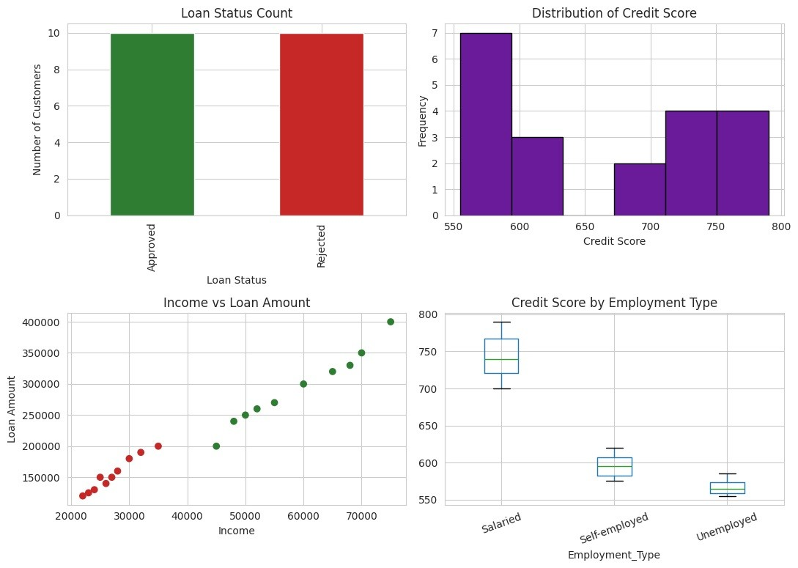
Observations
Observation No. | Description
1 | Customers with credit scores above 700 are mostly approved for loans.
2 | Salaried employees have a much higher loan approval rate than self-employed or unemployed applicants.
3 | Customers with higher incomes tend to receive approval for larger loan amounts.
4 | Unemployed customers are rejected in almost all cases in this dataset.
5 | No missing values or duplicate records were found in the dataset.
Conclusion
Credit score and employment type are the strongest factors influencing loan approval, followed by income level. Applicants with high credit scores, stable salaried employment, and higher incomes have a greater chance of loan approval and are more likely to receive larger loan amounts. The dataset contains no missing values or duplicate records, making it suitable for reliable analysis.
Question 5: Agriculture Crop Yield Dataset
Goal: Analyze crop yield based on rainfall, temperature, fertilizer usage, and soil type.
Dataset Information
Property | Value
Shape (Rows, Columns) | (20, 6)
Total Rows | 20
Total Columns | 6
Missing Values | 0
Duplicate Rows | 0
Column Data Types
Column Name | Data Type
Farm_ID | str
Rainfall_mm | int64
Temperature | int64
Fertilizer_kg | int64
Soil_Type | str
Crop_Yield_kg | int64
Descriptive Statistics (Numeric Columns)
Statistic | Rainfall_mm | Temperature | Fertilizer_kg | Crop_Yield_kg
Count | 20.0 | 20.0 | 20.0 | 20.0
Mean | 743.00 | 29.55 | 54.75 | 2820.00
Standard Deviation (Std) | 144.34 | 2.76 | 10.51 | 681.41
Minimum (Min) | 500.00 | 25.00 | 40.00 | 1800.00
25% (Q1) | 615.00 | 27.75 | 45.75 | 2175.00
50% (Median) | 770.00 | 29.00 | 54.50 | 2975.00
75% (Q3) | 857.50 | 32.00 | 60.50 | 3250.00
Maximum (Max) | 960.00 | 34.00 | 75.00 | 3900.00
Observations
Observation No. | Description
1 | Higher rainfall and greater fertilizer usage are both linked to higher crop yield.
2 | Sandy soil produces the lowest crop yield even with fertilizer application.
3 | Higher temperatures are generally associated with lower crop yield due to drier conditions.
4 | Loamy soil produces higher crop yields compared to other soil types.
5 | No missing values or duplicate records were found in the dataset.
Conclusion
Soil type and rainfall are the major factors influencing crop yield, while fertilizer usage further improves production, especially in Loamy soil. Higher rainfall combined with appropriate fertilizer application results in better crop productivity, whereas higher temperatures tend to reduce yield. The dataset is clean, with no missing values or duplicate records, making it suitable for reliable agricultural analysis.

Overall Summary
The same Exploratory Data Analysis (EDA) process was applied across all five datasets. Each dataset was examined by checking its structure, verifying data quality, computing descriptive statistics, identifying key patterns through analysis, and drawing meaningful conclusions. This systematic EDA approach supports informed decision-making in the domains of student performance, healthcare, retail sales, banking loan approval, and agriculture.

